General Instructions for Creating a Rack Profile
A Rack Profile is a depiction of the assembly of equipment, location and sizes of components and chassis within the rack.
Example:
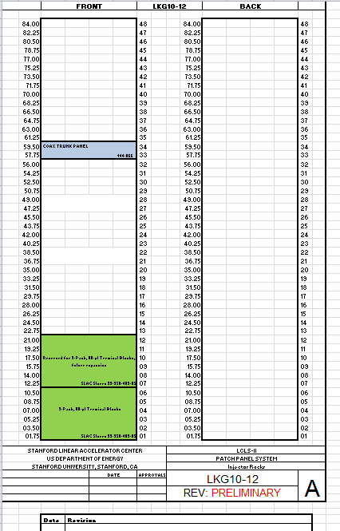
To create a rack profile, use the template which can be found by:
- Starting from the controls home page, go to CAPTAR Cables Database
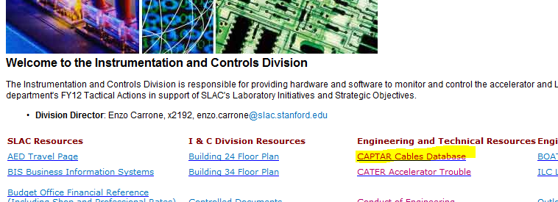
- Select How to Submit a Cable Installation Job
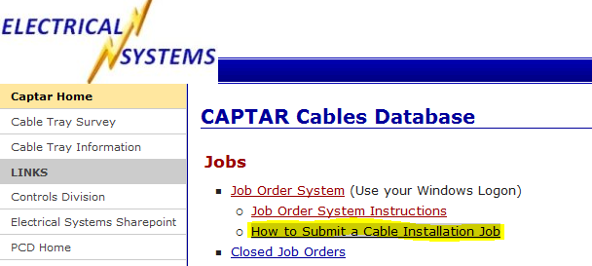
- Select New or Blank Rack Profile
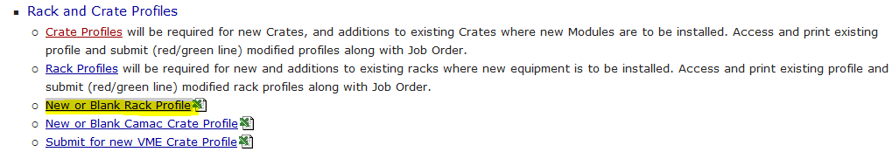

Filling out the Rack Profile:
- Fill out the bottom of the template.  - Project Name  - System  - Area of Installation  - Name of Engineer and extension  - Designer Coordinator and extension  - Name of Rack  - Revision Level  - Date and Revision Description | 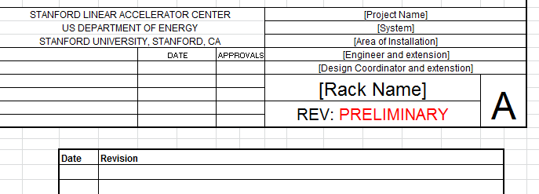
- Define region for use. Provide short description. | 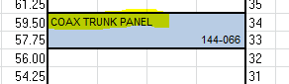
- In the bottom right of the defined region, list the chassis model # or relevant ID.
- Size of chassis must be noted and reflected.
- Cable feed through needs to be noted where applicable.

The rack profile will be a living document. Populate the rack profile template with as much information that is known at the time and save with appropriate project information and revision. As more information becomes available or is defined, update the rack profile document and revision.
Once the rack arrives, the current rack profile document should be printed and adhered to the rack. If there is a change to the rack profile after that time, a new copy must be made and SLAC cable shop notified of the revision change.
Since the cable shop uses the rack profile to assemble the rack, it is important to keep the following in mind when creating the Job Order.
- Note if patch panels are required.
- Note if terminal blocks are required.
- Note if cross connect blocks required.
- Note if the chassis requires slide out rails for a particular chassis.
- Power supplies may require additional support. Detail the support required and who purchases (provides) it. Will cable shop or system engineer purchase the required support?

